Lecture Notes
In this course we will make extensive use of MongoDB Compass for learning how to use MongoDB.
- Please download Compass from the MongoDB Download Center. If you downloaded Compass before today, please make sure you are using version 1.8 or later and upgrade if necessary.
- Install Compass on your computer from the download.
- Launch Compass.
When Compass opens you will see a page titled "Connect to Host".
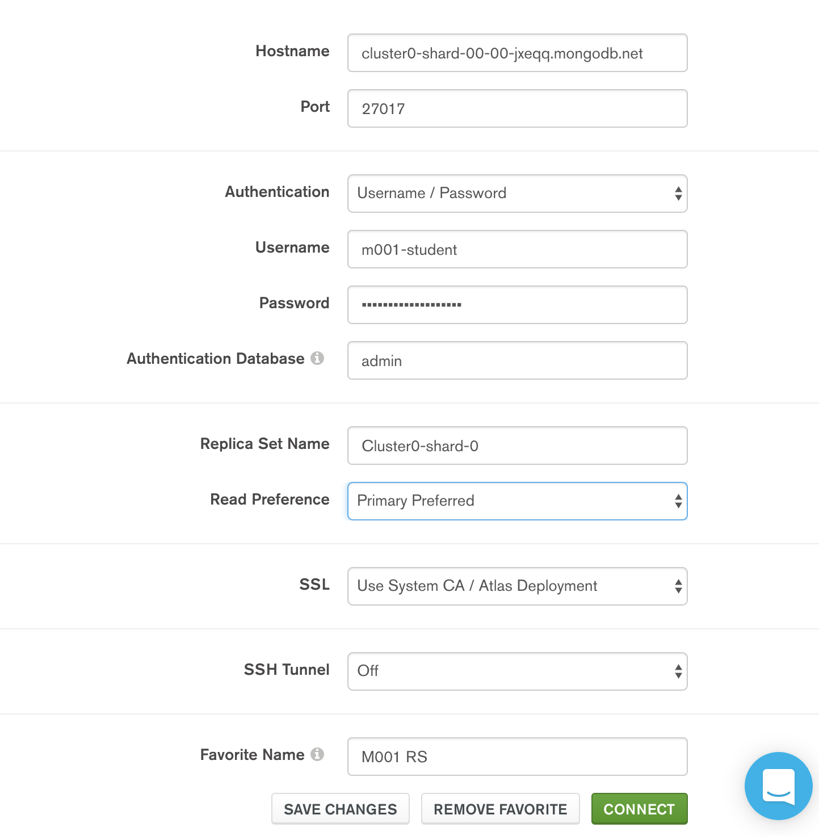
- Use the following information to complete this form, but do not click "Connect" yet.
Hostname: cluster0-shard-00-00-jxeqq.mongodb.net
Username: m001-student
Password: m001-mongodb-basics
Replica Set Name: Cluster0-shard-0
Read Preference: Primary Preferred
- Click "Add to Favorites" and enter M001 RS as the Favorite Name. Adding this connection as a favorite will enable you to easily connect to our class MongoDB deployment after closing and restarting Compass at some point in the future.
- Now, click "Connect" and load the databases in the M001 class MongoDB deployment.

